Editors - Properties Editor
Properties Editor 1
Contexts 1
Scene / Render 1
Object Data 2
Documentation 3

Properties Editor

The Properties Editor is used to edit data and properties for the Active Scene and the Active Object. It also contains lots of other functionality that you would expect to find in separate settings. Rendersettings. Materials, particle settings and and and.
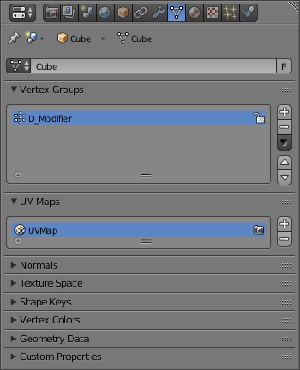
The Properties Editor with the Mesh tab selected.

Contexts
The Properties (or Buttons) Window shows several Contexts, which can be chosen via the icon row in the header.

Scene / Render
These tabs are used to add features, and to change properties for the Active Scene.
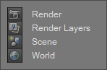
Scene / Render tabs.
Render
Everything related to render output (dimensions, anti-aliasing, performance etc).
Render Layers
Render Layers and Passes.
Scene
Gravity, Units to use, Keying Sets, Color Management, Audio settings, Physics, and scene simplification options.
World
Environmental lighting, sky, mist and Ambient Occlusion.

Object Data
These tabs are used to add features, and to change properties for the Active Object (and other active elements, material, curve... etc).
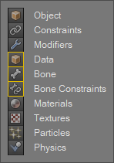
Object Data tabs.
The Object Data tabs shown depend on what type of object was selected last (The Active Object).
Features unique to the object type are usually added to the Data and Bone tabs, highlighted in yellow.
Object
Transformations, display options, visibility settings (via layers) duplication settings and animation information (regarding Object position).
Constraints
Used to control an Object’s transform (position, rotation, scale), tracking and relationship properties.
Modifiers
Array, Mirror, Subdivision Surface, Armature, Cast.
Object Data
Settings for the objects data, depending on the Object Type.
Bone
Armature Bone settings.
Bone Constraints
Armature Bone constraints.
Materials
Properties of the surface (color, specularity, transparency, etc).
Textures
Used by materials, world and brushes to provide additional details.
Particles
Hair and Emitter particles.
Physics
Properties relating to Cloth, Force Fields, Collision, Fluid and Smoke Simulation.

Documentation
Rendering is mainly documented in its own section, there is also information on materials and textures.
- Render
Scene features are mainly documented in the data-system, though some tools are added to different sections.
- Scenes
- Keying Sets
The Object features are usually documented in the ‘Objects’ part of the 3D Viewport Section.
- Modeling
The other features each have their own section in the manual.
- Constraints
- Modifiers
- Particles
- Physics

